|  |  |
| --- | --- |
| Name: | Prerna Sunil Jadhav |
| Sap  Id: | 60004220127 |
| Class: | T. Y. B.Tech (Computer Engineering) |
| Course: | Data Mining and Warehouse Laboratory |
| Course Code: | DJ19CEL501 |
| Experiment  No.: | 07 |

**AIM:** Perform OLAP operations such as Rollup,Drill down,Slice and Dice, Pivot on Data Warehouse.

To create Pivot of Table using MS Excel

Follow these steps:

1. Start with M.S Excel.

2. In excel sheet create 4 columns PRODUCT, ORIGIN, DAY OF SALE, SOLD UNITS (FACT COLUMN).

3. Insert around fifty rows of data.

4. Save the table data.

5. Go to Insert Tab-> click on Pivot Table-> New work sheet-> Ok.

6. Right side you will find pivot table fields.

It contains all columns of our table that we created. Select product in rows,

Days in column,

Unit sold in ∑ values.

Later apply filter using Origin.

Also we can flip the rows & columns or combine together as rows only to see different views of same data.

Dataset:

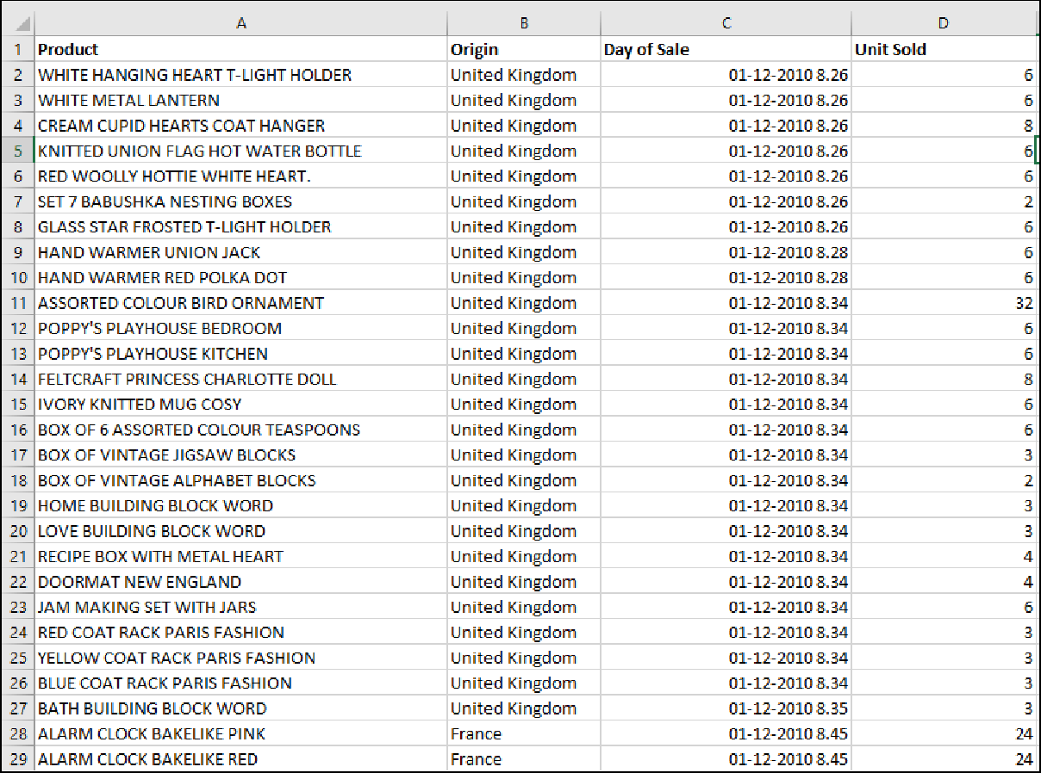

CASE 1:

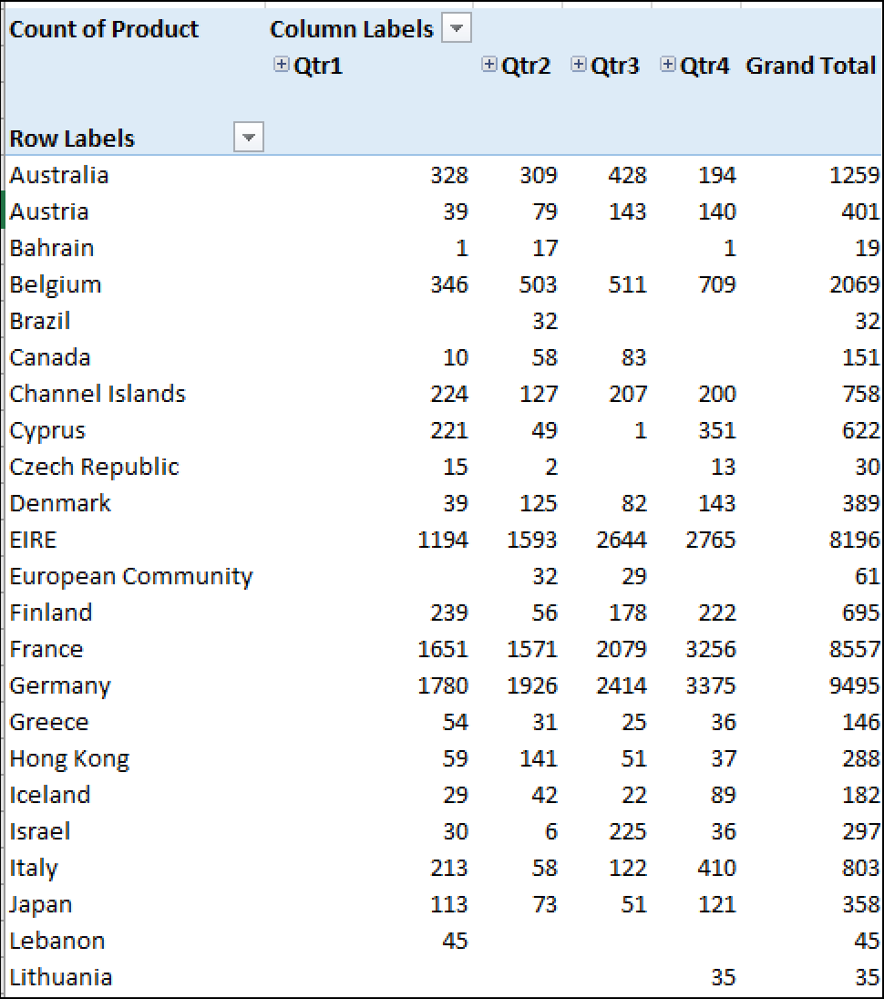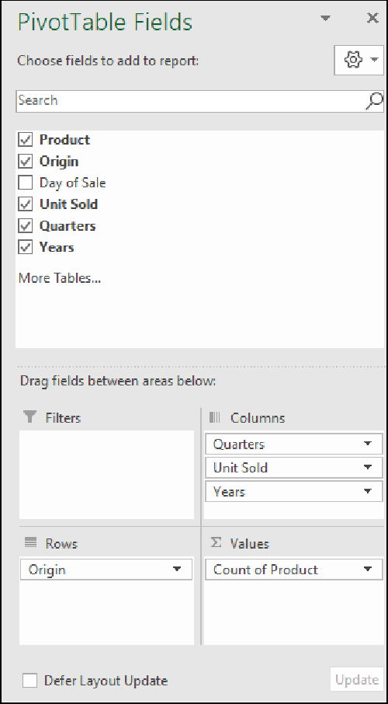CASE 2: